

**LIGHTS DEFECT DETECTION SYSTEM**

**User Manual**

**V1.0**

Table of Contents

1. Video Capture Application 1

1.1 Starting and Stopping the Application 2

1.2 UI Components 3

1.3 Configurations 4

1.4 Configurations Default Value 7

2. Lights Detector Application 8

2.1 Starting and Stopping the Application 9

2.2 UI Scenarios 10

2.3 UI Components 12

2.4 Lights Status 12

2.5 Configurations 13

2.6 Configurations Default Value 14

3. Updating the System 15

3.1 Updating Video Capture 15

3.2 Updating Lights Detector 15

4. Troubleshooting 16

4.1 General Issues 16

4.1.1 DELL monitor screen is black / could not connect to the PC 16

4.1.2 Microsoft Defender SmartScreen pop up 18

4.2 Video Capture Issues 18

5. Figure 28 shows a sample of error message in Video Capture. The error message will describe the possible cause that triggers the error. To get more details on the error, check the Video Capture terminal windows. 18

5.1.1 Camera is not connected 18

5.2 Lights Detector Issues 19

5.2.1 Camera is not connected 19

5.2.2 Configurations file could not be found 19

**Table of Figures**

Figure 1: Video Capture UI in browser 1

Figure 2: Video Capture Icon 1

Figure 3: Saved Folder Icon 1

Figure 4: VideoCapture-src Icon 2

Figure 5: Video Capture's Terminal Window 2

Figure 6: Video Capture UI components 3

Figure 7: Configurations in Video Capture 4

Figure 8: Add New Car Model configuration 4

Figure 9: Delete Selected Car Model configuration 5

Figure 10: Video Save Folder configuration 5

Figure 11: Front Camera RTSP configuration 5

Figure 12: Front Camera Width configuration 5

Figure 13: Front Camera Height configuration 6

Figure 14: Rear Camera RTSP configuration 6

Figure 15: Rear Camera Width configuration 6

Figure 16: Rear Camera Height configuration 6

Figure 17: Frame Rate configuration 6

Figure 18: Video Codec configuration 7

Figure 19: Front Lights Detector Icon 8

Figure 20: Rear Lights Detector Icon 8

Figure 21: Perodua Configurations folder 8

Figure 22: Logs folder 8

Figure 23: Lights Detector's terminal window 9

Figure 24: Lights Detector UI Scenario 1 10

Figure 25: Lights Detector UI Scenario 2 10

Figure 26: Lights Detector UI Scenario 3 11

Figure 27: Lights Detector UI Components 12

Figure 28: Sample of error message in Video Capture 18

Figure 29: Sample of error message in Lights Detector 19

**List of Tables**

Table 1: Video Capture Configurations Default Value 7

Table 2: Lights Detector default configurations 14

# Video Capture Application

Video Capture application is used to record video using both front and rear camera. The application will be hosted in localhost on port 8501.

Figure : Video Capture UI in browser

**VIDEO CAPTURE**

Figure : Video Capture Icon

Video Capture application uses a batch (.bat) file to automatically host the application on localhost. The shortcut to the batch file can be found in Desktop.

**SAVED VIDEOS FOLDER**

Figure : Saved Folder Icon

Contains the recorded videos and its metadata.

**VIDEO CAPTURE – SRC FOLDER**

Figure : VideoCapture-src Icon

Video Capture – Src folder contains the source code for Video Capture applications

## Starting and Stopping the Application

Starting Video Capture

1. Double click on the Video Capture Icon (Figure 2).
2. A terminal window (Figure 5) will pop up.
3. After the application is up and running, a browser window will be opened automatically. ***Note:*** *If the browser did not start automatically, open a browser and enter the following URL: http://localhost:8501*

Figure : Video Capture's Terminal Window

Stopping Video Capture

1. Close the browser window (Figure 1).
2. Close the terminal window (Figure 5).

## UI Components

d.

c.

b.

a.

Figure : Video Capture UI components

1. **Car Models**

Displays a checklist of existing car models. Tick the car models that are expected to be present in the recording.

1. **Descriptions**

Describe the condition of cars in the video. For example, “MYVI has faulty signal lights”.

1. **Video Length**

Insert the duration of the recorded video in minutes and seconds. For example, set minutes to 60 and seconds to 0 to record for 1 hour. Set minutes to 0 and seconds to 30 to record for 30 seconds.

1. **Begin Recording**

The button to start recording.

## Configurations

Figure : Configurations in Video Capture

1. **Add New Car Model**

To add a new car model to car model list. Enter the name of the new car model and click “Add” button.

Figure : Add New Car Model configuration

1. **Delete Car Model**

To delete a car model, tick on the car models checkbox. A “Delete Selected Car” button will appear. Click on the button to delete the car model.

Figure : Delete Selected Car Model configuration

1. **Video Save Folder**

Path to the folder to save the recorded videos. If the path does not exist, the application will create a folder automatically.

Figure : Video Save Folder configuration

1. **Front Camera RTSP**

RTSP URL for front camera.

Figure : Front Camera RTSP configuration

1. **Front Camera Width**

Video’s width.

Figure : Front Camera Width configuration

1. **Front Camera Height**

Video’s height.

Figure : Front Camera Height configuration

1. **Rear Camera RTSP**

RTSP URL for rear camera.

Figure : Rear Camera RTSP configuration

1. **Rear Camera Width**

Video’s width.

Figure : Rear Camera Width configuration

1. **Rear Camera Height**

Video’s height.

Figure : Rear Camera Height configuration

1. **Frame Rate (FPS)**

Video’s frame rate.

Figure : Frame Rate configuration

1. **Video Codec**

Video’s codec. Available codecs for Video Capture application are mp4v, h264, and h265.

Figure : Video Codec configuration

## Configurations Default Value

Table : Video Capture Configurations Default Value

|  |  |
| --- | --- |
| **Configurations** | **Default Value** |
| Video Save Folder |  |
| Front Camera RTSP |  |
| Front Camera Width | 1920 |
| Front Camera Height | 1080 |
| Rear Camera RTSP |  |
| Rear Camera Width | 1920 |
| Rear Camera Height | 1080 |
| Frame Rate (FPS) | 30 |
| Video Codec | mp4v |

# Lights Detector Application

**APPLICATION (.EXE) FILES**

Figure : Front Lights Detector Icon

Figure : Rear Lights Detector Icon

Lights Detection Application is divided into two applications, “Front Lights Detector” and “Rear Lights Detector”. As the name suggested, “Front Lights Detector” will be using the front camera to detect front lights of the cars while “Rear Lights Detector” will be used for rear lights.

**PERODUA_CONFIGURATIONS FOLDER**

Figure : Perodua Configurations folder

All configurations for Light Detection Application are stored in this folder. There are two types of configurations, application configurations and car models configurations which are placed in app_configs folder and car_configs folder respectively.

**app_configs folder**

The configurations file for the application is also separated for front and rear, which can be found in *perodua_configurations/ipconfig’s* folder.

**car_configs folder**

The configurations file for the application is also separated for front and rear, which can be found in *perodua_configurations/app_configs* folder.

**LOGS FOLDER**

Figure : Logs folder

Contains log files for Light Detection application for front and rear.

## Starting and Stopping the Application

Starting Lights Detector

1. Double click on the Front Lights Detector Icon (Figure 19).
2. A terminal window (Figure 23) will pop up. ***Note:*** *Lights Detector takes around 30 seconds to load.*
3. A display window will open displaying the camera output. ***Note:*** *For front lights, the display window will appear at the left side. For rear lights, the display window will appear at the right side.*
4. Repeat all the steps for Rear Lights Detector.

Figure : Lights Detector's terminal window

Stopping Lights Detector

1. Click on the “X” button on the display window or close the terminal window.

## UI Scenarios

**Scenario 1**

**When no car is detected at the center of the screen:**

Displays the full size of frames captured by camera.

Figure : Lights Detector UI Scenario 1

**Scenario 2**

**When a car is detected at the center of the screen but all lights are turned off:**

Displays zoomed in frames of the car.

The panels for lights detection will appear. The border of all panels is red.

Figure : Lights Detector UI Scenario 2

**Scenario 3**

**When a car is detected at the center of the screen and lights are turned on:**

Displays zoomed in frames of a car detected at the center of the screen.

The panels for lights detection will appear. The border of the panels turned green or yellow.

Figure : Lights Detector UI Scenario 3

## UI Components

Figure : Lights Detector UI Components

**Checklist panels** shows the status of both right and left lights in the past 1 minute.

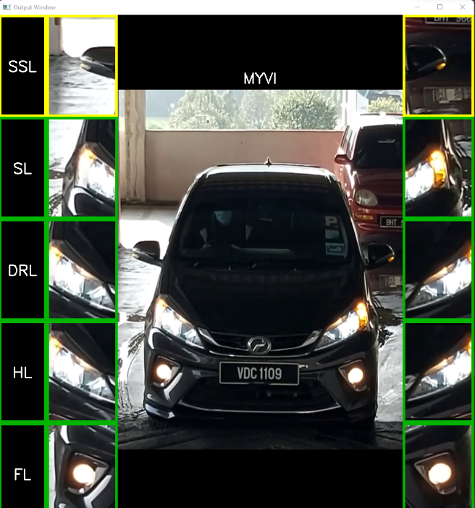

**Car panels** shows the live feed of the car in the center.

**Lights panels** shows live feed of the detected lights and its status.

## Lights Status

Lights status is indicated by the colour of borders in checklist panels and lights panels. The status can be classified into three, which are represented by the colour green, yellow, and red.

**Green**

Light is detected in the current frame.

**Yellow**

Light is not detected in the current frame, but it was detected a few seconds ago.

***Note****: The duration for yellow border to appear before turning red can be adjusted in the configurations file.*

**Red**

Light is not detected.

## Configurations

1. **source**

The RTSP URL of IP camera.

1. **debug**

Debug view. Set to ‘true’ to display debug view.

1. **frame_duration**

The time interval for the application to start processing.

1. **car_expired_duration**

The duration (in seconds) for car detector to be expired. For example, if the current car model is not present at the center of the screen for 5 seconds, the UI will refresh.

1. **lamps_expired_duration**

The duration (in seconds) for light detector to be expired. For example, if a left headlight does not light up for 30 seconds, the left headlight box will become red.

1. **summary_expired_duration**

The duration (in seconds) for checklist view to be expired. For example, if **both** headlights do not light up for 1 minute, the checklist headlight box will become red.

1. **object_tracking**

To enable object tracking.

1. **yolo_weight**

The filename of general YOLO model to detect different car models.

1. **device**

CUDA device to run YOLO. For example, ‘0’ or ‘0, 1, 2, 3’ or ‘cpu’. Leave empty to use default.

1. **dnn**

To enable deep neural network.

Note: Deep neural network takes a lot of computing power. It is not recommended to use dnn for this use case.

1. **imgsz**

Image size to use when running YOLO. Should use the same size used during training, which is [1280, 720].

1. **half**

To enable half-precision inference to speed up computing process.

1. **general_conf_thres**

Confidence threshold for car models detection.

1. **specific_conf_thres**

Confidence threshold for lights detection

1. **iou_thres**

Overlapping (Intersection Over Union) threshold.

## Configurations Default Value

Table : Lights Detector default configurations

|  |  |
| --- | --- |
| **Configurations** | **Default Value** |
| source |  |
| debug | false |
| frame_duration | 1 |
| car_expired_duration | 10 |
| lamps_expired_duration | 30 |
| summary_expired_duration | 60 |
| object_tracking | false |
| yolo_weight | cars_s6_best_2022-6-21.pt |
| device |  |
| dnn | false |
| imgsz | [1280, 720] |
| half | true |
| general_conf_thres | 0.45 |
| specific_conf_thres | 0.1 |
| iou_thres | 0.15 |

# Updating the System

To update the system, simply replace the current files and folders with the new one. For Video Capture, only VideoCapture-src folder needs to be updated. For Lights Detector, user can choose whether to update only the applications file, only configurations folder, or both.

## Updating Video Capture

1. Get the latest version of VideoCapture-src.
2. Delete the current VideoCapture-src folder (Figure 4) in Desktop.
3. Copy and paste the new version of VideoCapture-src to the Desktop.

## Updating Lights Detector

Updating the Application Files

1. Get the latest version of Front Lights Detector.exe and Rear Lights Detector.exe files.
2. Delete the current Front Lights Detector.exe (Figure 19) and Rear Lights Detector.exe (Figure 20) files.
3. Copy and paste the new version of Front Lights Detector.exe and Rear Lights Detector.exe files.

Updating the Configuration Files

1. Get the latest version of perodua_configurations folder.
2. Delete the current perodua_configurations folder (Figure 21).
3. Copy and paste the new version of perodua_configurations folder.

Updating both Application and Configuration Files

1. Do all the steps for Updating the Application Files and Updating the Configuration Files.

# Troubleshooting

## General Issues

General Issues describes the issues that might happen due to the PC’s settings or Windows system.

### DELL monitor screen is black / could not connect to the PC

1. Connect the TV via HDMI cable and turn on the TV.
2. Click on windows start button and go to settings.

1. Click on “System”.

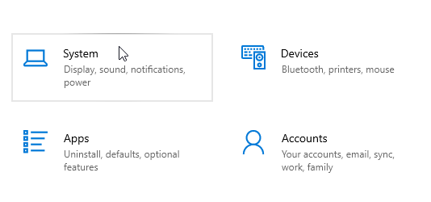

1. Go to “Display” tab and scroll to the bottom.
2. Click on “Advanced display settings”.

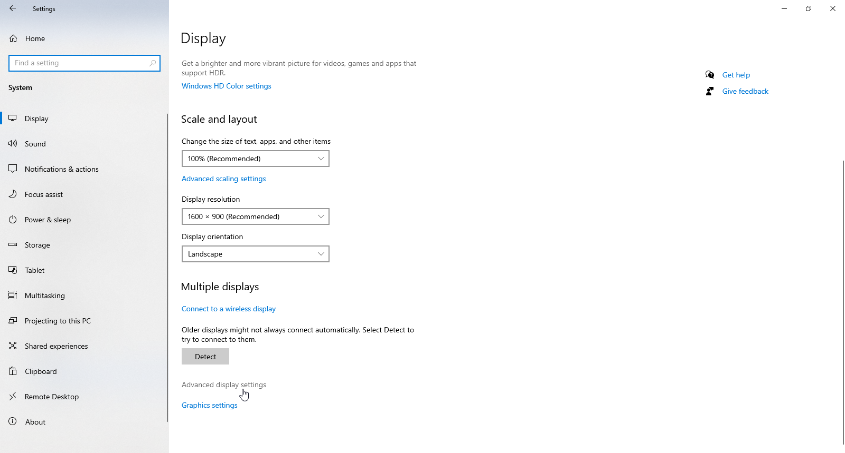

1. Make sure the display is DELL E2016HV.
2. Change the “Refresh rate” to 60Hz.

### Microsoft Defender SmartScreen pop up

If Microsoft Defender SmartScreen pops up, click on “More Info” and click “Run anyway”

## Video Capture Issues

Figure : Sample of error message in Video Capture

# Figure 28 shows a sample of error message in Video Capture. The error message will describe the possible cause that triggers the error. To get more details on the error, check the Video Capture terminal windows.

### Camera is not connected

1. Check whether all the camera cables are connected to the PC.
2. Check whether the camera is turned on.
3. Check whether the RTSP URL is correct.

## Lights Detector Issues

Figure : Sample of error message in Lights Detector

Figure 29 shows a sample of error popup dialog. The popup dialog will show a general error message of the possible cause of the error. To get more details on the error, check the latest log file in logs folder.

### Camera is not connected

1. Check whether all the camera cables are connected to the PC.
2. Check whether the camera is turned on.
3. Check whether the RTSP URL is correct.

### Configurations file could not be found

1. Make sure the “perodua_configurations” folder is in “Desktop”.
2. Go in the “perodua_configurations” folder and make sure “app_configs” and “car_configs” folder exist.
3. Make sure “settings_front.json” and “settings_rear.json” exist. **Note:** If the settings file does not exist, create a .json file and copy the value in Section 2.6 Configurations Default Value.
4. If the above steps did not resolve the issue, check the latest log file in logs folder to get more details.